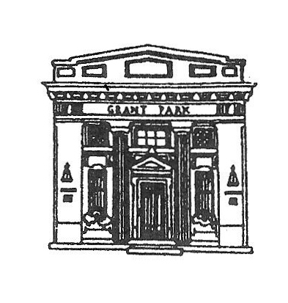
President

GRANT PARK VILLAGE BOARD
AGENDA
VILLAGE HALL
Monday March 7, 2016
6:00 PM

Martin Roth

Clerk
Scott Dillman
Treasurer
Douglas Graves
Trustees
Dana R. Dickson
Mike Malkowski
Debra Morgan
Jill Morse
Laura Veldhuizen
William J. Wold

- CALL THE MEETING TO ORDER
- PLEDGE TO FLAG
- ROLL CALL
- APPROVAL OF PREVIOUS MEETING(S) MINUTES
- APPROVAL OF 2/01/16 MEETING MINUTES
- PUBLIC COMMENTS:COMMENTS ARE LIMITED TO 3 MINUTES PURSUANT TO ORDINANCE O-1-15-1, RULE 22-H
If you wish to hold a discussion with the Village Board you must be on the published agenda. Agendas are published the Thursday prior to Monday meeting.
St. Peters United Church of Christ
- APPROVE BILLS FOR PAYMENT
- APPROVE PAYROLL
- DEPARTMENT REPORTS
- CLERK SCOTT DILLMAN
- ATTORNEY'S REPORT JIM ROWE
- ENGINEER'S REPORT NEIL PIGGUSH
- STREET & ALLEY COMMITTEE CHAIRMAN LAURA VELDHUIZEN
STREETS & ALLEY COMMISSIONER JOHN HENSON
- FINANCE COMMITTEE CHAIRMAN DANA DICKSON
VILLAGE TREASURER DOUG GRAVES
DISCUSS COLLECTION PROCEDURES
- SEWER/GARBAGE COMMITTEE CHAIRMAN DEB MORGAN
SEWER COMMISSIONER JOHN BOBERA
NPDES PERMIT
2016/17 SEWER PROJECTS
RECENT SEWER/SEPTIC ISSUE
FARMER'S MARKET ACTIVITIES FOR 2016 SEASON
WAGON PROJECT PROGRESS
- BUILDINGS & GROUNDS COMMITTEE CHAIRMAN BILL WOLD
APPROVE HIRE OF JUNE SWART PART TIME AT $8.25 AN HOUR
REPORT ON CABIN FEVER PARK FUNDRAISER
VOTE ON GETTING BIDS TO PAVE PARK PARKING LOT WITH TIF FUNDS
- ORDINANCES & INSURANCE COMMITTEE CHAIRMAN JILL MORSE
FIRST READING ORDINANCE O-3-16-1 AMENDING TITLE 7(PUBLIC WAYS AND PROPERTY)
- LAW ENFORCEMENT COMMITTEE CHAIRMAN MIKE MALKOWSKI
POLICE CHIEF CARL FREY
- VILLAGE PRESIDENT MARTIN ROTH
VOTE ON RESOLUTION R-3-16-1 AUTHORIZING THE EXECUTION OF A MEMORANDUM OF UNDERSTANDING
- MOTION TO ENTER EXECUTIVE SESSION TO DISCUSS PERSONNEL AND LITIGATION
- MOTION TO TAKE ACTION IF NECESSARY
MOTION TO ADJOURN

