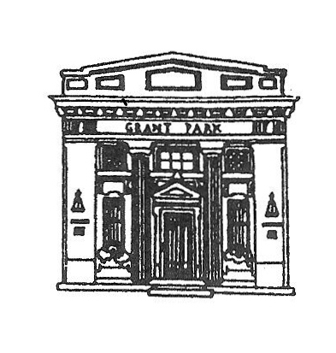
President

GRANT PARK VILLAGE BOARD
AGENDA
VILLAGE HALL
Monday February 5, 2018
6:00 PM

Martin Roth

Clerk
Scott Dillman
Treasurer
Douglas Graves
Trustees
Bill Coats
Dana R. Dickson
William Gerry Morgan
Jill Morse
Laura Veldhuizen
Susie Wiedl

- CALL THE MEETING TO ORDER
- PLEDGE TO FLAG
- ROLL CALL
- APPROVAL OF PREVIOUS MEETING(S) MINUTES, Jan 2 2018 and Jan 16 2018
- PUBLIC COMMENTS:COMMENTS ARE LIMITED TO 3 MINUTES PURSUANT TO ORDINANCE O-1-15-1, RULE 22-H
If you wish to hold a discussion with the Village Board you must be on the published agenda. Agendas are published the Thursday prior to Monday meeting.
Dustin Price
Girl Scout Troop 70285
Bob Roviaro
- APPROVE BILLS FOR PAYMENT
- APPROVE PAYROLL
- DEPARTMENT REPORTS
- CLERK SCOTT DILLMAN
- ATTORNEY'S REPORT JEFF TAYLOR
- ENGINEER'S REPORT NEIL PIGGUSH
- STREET & ALLEY COMMITTEE CHAIRMAN LAURA VELDHUIZEN
STREETS & ALLEY COMMISSIONER JOHN HENSON
- FINANCE COMMITTEE CHAIRMAN DANA DICKSON
VILLAGE TREASURER DOUG GRAVES
- SEWER/GARBAGE COMMITTEE CHAIRMAN GERRY MORGAN
SEWER COMMISSIONER JOHN BOBERA
- BUILDINGS & GROUNDS COMMITTEE CHAIRMAN JILL MORSE
VOTE TO APPROVE REPLACEMENT OF WEST DOOR AT PARK NOT TO EXCEED $3500
- ORDINANCES & INSURANCE COMMITTEE CHAIRMAN SUSIE WIEDL
- LAW ENFORCEMENT COMMITTEE CHAIRMAN BILL COATS
POLICE CHIEF CARL FREY
SWEAR IN JAMES VELA PART TIME POLICE OFFICER AT $17 AN HOUR
- VILLAGE PRESIDENT MARTIN ROTH
- MOTION TO ENTER EXECUTIVE SESSION TO DISCUSS PERSONNEL AND LITIGATION
- MOTION TO TAKE ACTION IF NECESSARY
MOTION TO ADJOURN

