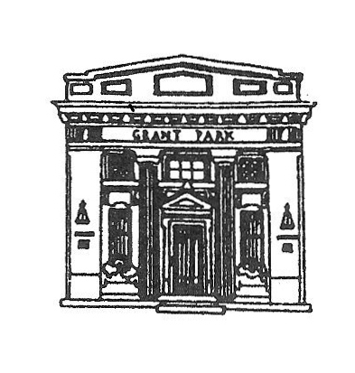
President

GRANT PARK VILLAGE BOARD
AGENDA
VILLAGE HALL
Monday May 7, 2018
6:00 PM

Martin Roth

Clerk
Scott Dillman
Treasurer
Douglas Graves
Trustees
Bill Coats
Dana R. Dickson
William Gerry Morgan
Jill Morse
Laura Veldhuizen
Susie Wiedl

- CALL THE MEETING TO ORDER
- PLEDGE TO FLAG
- ROLL CALL
- APPROVAL OF PREVIOUS MEETING(S) MINUTES,
- PUBLIC COMMENTS:COMMENTS ARE LIMITED TO 3 MINUTES PURSUANT TO ORDINANCE O-1-15-1, RULE 22-H
If you wish to hold a discussion with the Village Board you must be on the published agenda. Agendas are published the Thursday prior to Monday meeting.
Dennis Granger
- APPROVE BILLS FOR PAYMENT
- APPROVE PAYROLL
- DEPARTMENT REPORTS
- CLERK SCOTT DILLMAN
- ATTORNEY'S REPORT JEFF TAYLOR
- ENGINEER'S REPORT NEIL PIGGUSH
- STREET & ALLEY COMMITTEE CHAIRMAN LAURA VELDHUIZEN
STREETS & ALLEY COMMISSIONER JOHN HENSON
- FINANCE COMMITTEE CHAIRMAN DANA DICKSON
VILLAGE TREASURER DOUG GRAVES
APPROVE FISCAL YEAR 2019 BUDGET
- SEWER/GARBAGE COMMITTEE CHAIRMAN GERRY MORGAN
SEWER COMMISSIONER JOHN BOBERA
- BUILDINGS & GROUNDS COMMITTEE CHAIRMAN JILL MORSE
VOTE TO APPROVE FRIDAY NIGHT BAND-JUST ROLL WITH IT FOR $500
VOTE TO APPROVE SOUND GUY FOR SATURDAY NIGHT- ROSE AUDIO FOR $800
VOTE TO APPROVE FIREWORKS- CENTRAL STATES FIREWORKS FOR $5,200
VOTE TO APPROVE PORTA POTTY RENTAL AND HANDWASHING STATIONS - LEE’S RENTALS FOR $850
VOTE TO APPROVE 40X100 ($1,150) TENT AND 40X40 ($450) TENT - SUNRISE TENTS FOR $1600
VOTE TO APPROVE SOCCER/BASEBALL RENTAL FOR KIDS AREA - 3 DAYS FOR $400 WITH A DEPOSIT DUE OF $100. LEE’S RENTALS.
VOTE TO APPROVE BIG RAFFLE. CASH PRIZES - 1ST PRIZE-$1,000, 2ND PRIZE-$500, 3RD PRIZE-$250, 4TH PRIZE- $150, 5TH PRIZE- $50, 6TH PRIZE- $50
- ORDINANCES & INSURANCE COMMITTEE CHAIRMAN SUSIE WIEDL
SECOND READING - CONSIDERATION AND APPROVAL OF AN ORDINANCE APPROVING AN ASSET PURCHASE AGREEMENT AND THE SALE OF SURPLUS REAL PROPERTY AND PERSONAL PROPERTY IN THE VILLAGE OF GRANT PARK, KANKAKEE COUNTY, ILLINOIS – SALE OF WASTEWATER SYSTEM AND RELATED REAL AND PERSONAL PROPERTY TO AQUA ILLINOIS, INC.
- LAW ENFORCEMENT COMMITTEE CHAIRMAN BILL COATS
POLICE CHIEF CARL FREY
- VILLAGE PRESIDENT MARTIN ROTH
RECOGNIZE BRIAN DUNCAN FOR AWARD PRESENTED FROM EASTERN ILLINOIS SHERIFFS ASSOCIATION
- MOTION TO ENTER EXECUTIVE SESSION TO DISCUSS PERSONNEL AND LITIGATION
- MOTION TO TAKE ACTION IF NECESSARY
MOTION TO ADJOURN

