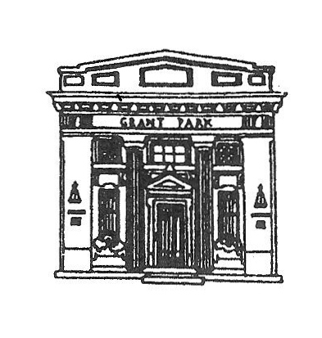
President

GRANT PARK VILLAGE BOARD
AGENDA
VILLAGE HALL
Tuesday January 3, 2017
6:00 PM

Martin Roth

Clerk
Scott Dillman
Treasurer
Douglas Graves
Trustees
Dana R. Dickson
Mike Malkowski
Debra Morgan
Jill Morse
Laura Veldhuizen
William J. Wold

- CALL THE MEETING TO ORDER
- PLEDGE TO FLAG
- ROLL CALL
- APPROVAL OF PREVIOUS MEETING(S) MINUTES
- PUBLIC COMMENTS:COMMENTS ARE LIMITED TO 3 MINUTES PURSUANT TO ORDINANCE O-1-15-1, RULE 22-H
If you wish to hold a discussion with the Village Board you must be on the published agenda. Agendas are published the Thursday prior to Monday meeting.
- APPROVE BILLS FOR PAYMENT
- APPROVE PAYROLL
- DEPARTMENT REPORTS
- CLERK SCOTT DILLMAN
- ATTORNEY'S REPORT JIM ROWE
- ENGINEER'S REPORT NEIL PIGGUSH
- STREET & ALLEY COMMITTEE CHAIRMAN LAURA VELDHUIZEN
STREETS & ALLEY COMMISSIONER JOHN HENSON
- FINANCE COMMITTEE CHAIRMAN DANA DICKSON
VILLAGE TREASURER DOUG GRAVES
- SEWER/GARBAGE COMMITTEE CHAIRMAN DEB MORGAN
SEWER COMMISSIONER JOHN BOBERA
- BUILDINGS & GROUNDS COMMITTEE CHAIRMAN BILL WOLD
UPDATE ON COMMUNITY BUILDING AIR CONDITIONER
REPORT ON CHRISTMAS DAY DINNER
VOTE ON NEW HIRE KATHY BUTTLE PART TIME OFFICE POSITION AT $10 AN HOUR.
VOTE ON BUYING NEW TABLES AND CHAIRS FOR COMMUNITY PARK WITH FUNDS RAISED BY FEST COMMITTEE NOT TO EXCEED $2500.00
- ORDINANCES & INSURANCE COMMITTEE CHAIRMAN JILL MORSE
- LAW ENFORCEMENT COMMITTEE CHAIRMAN MIKE MALKOWSKI
POLICE CHIEF CARL FREY
- VILLAGE PRESIDENT MARTIN ROTH
- MOTION TO ENTER EXECUTIVE SESSION TO DISCUSS PERSONNEL AND LITIGATION
- MOTION TO TAKE ACTION IF NECESSARY
MOTION TO ADJOURN

